**Our Farm Partners**

**I provide 4 5 image make them as slides**

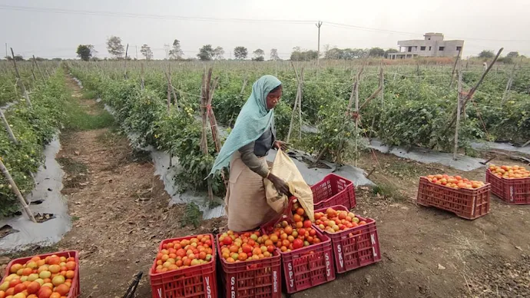

**Then, three boxes below with these details**

**Dinesh Foujdar – *Founder & CEO***

Dinesh Foujdar, a Postgraduate from **IIT Jodhpur**, founded this venture with the vision of delivering **fresh, healthy, and affordable vegetables** to every household.

Mob. 7023628056 Email. Veghigh001@gmail.com

**Manoj Jat – *Operations Head***

Manoj Jat leads the **operations and logistics** of the venture, ensuring that vegetables travel from farms to customers’ homes in the freshest condition possible.

Mob. 8302XXXXXX Email. info@veghigh.in

**Mohit Jat – *Marketing Manager***

As the Marketing Manager, Mohit Jat is the creative force behind spreading the brand’s message of **healthy and organic living**.

Mob. 7310XXXXXX Email. info@veghigh.in